Analyzing the update ability of a join view
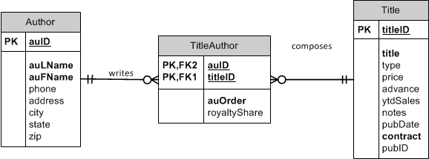

Consider this view:
CREATE OR REPLACE VIEW Oaklanders
AS
SELECT auFName AS First, auLName AS Last, t.titleID, title
FROM Author a JOIN TitleAuthor ta ON a.auID = ta.auID
JOIN Title t ON ta.titleID = t.titleID
WHERE city = 'Oakland'
AND state = 'CA';

Author table |  | TitleAuthor | Title Table
First (auLName) | Last (auFName) |  | t.titleID | title

Is this view updateable?
- Yes.
How?
- First, determine the key-preserved table (without regard for the attributes actually selected in the SELECT clause)
  - The key-preserved table will generally be on the "many" side of a one-to-many relationship. And it is often a joining table. In this case, TitleAuthor is on the many side of "writes" and of "composes".
- A DELETE statement against this view will delete rows from the TitleAuthor table.
- Only the fields from TitleAuthor could be edited with an UPDATE. Our SELECT clause does not include any fields from TitleAuthor, so you cannot use the UPDATE statement or the INSERT statement.

Try it!
- Delete statement
DELETE FROM Oaklanders
WHERE titleID = 'BU1032';
ROLLBACK;

Insert Statement
INSERT INTO Oaklander
VALUES ('Tanya', 'G', 'PC1233', 'DB is Fun');
*FAILS because the select clause doesn’t have any fields from our key-preserved table.

Consider this view:
CREATE OR REPLACE VIEW Oaklanders
AS
SELECT auFName AS First, auLName AS Last, ta.titleID, title
FROM Author a JOIN TitleAuthor ta ON a.auID = ta.auID
JOIN Title t ON ta.titleID = t.titleID
WHERE city = 'Oakland'
AND state = 'CA';

Author table |  | TitleAuthor | Title table
auFName | auLName | ta.titleID | title

Is this view updateable?
- Yes.
Why and how?
- TitleAuthor is the key-preserved table.
- The titleID field comes from the TitleAuthor table.
- Inserts cannot be performed because the view does not include the required fields of ta.titleID and ta.auOrder
- Updates and deletes are allowed (provided the updates do not violate any other constraints).
Try it!
- Update statement
UPDATE Oaklanders
SET titleID = 'BU7832'
WHERE titleID = 'BU1032';

Insert a record so that we can see this work
Insert into title (titleID, title, contract) values ('TL1111','DB is the best',1);

Now update
UPDATE Oaklanders
SET titleID = 'TL1111'
WHERE titleID = 'BU7832';

Check that our new row is there.
SELECT *
FROM TitleAuthor
WHERE titleID IN ('BU7832', 'TL1111');

ROLLBACK;
- Delete statement
DELETE FROM Oaklanders
WHERE titleID = 'BU1032';
ROLLBACK;

Consider this view:
CREATE OR REPLACE VIEW Oaklanders
AS
SELECT ta.auID, auFName AS First, auLName AS Last, ta.titleID, title, ta.auOrder
FROM Author a JOIN TitleAuthor ta ON a.auID = ta.auID
JOIN Title t ON ta.titleID = t.titleID
WHERE city = 'Oakland'
AND state = 'CA';

Author Table |  | TitleAuthor Table |  |  | Title Table
auFName | auLName | auOrder | auID | titleID | title

Is this view updateable?
- Yes!
Why and how?
- TitleAuthor is the key-preserved table.
- The titleID field comes from the TitleAuthor table.
- Inserts can be performed because the view does include all required fields (provided the inserts do not violate any other constraints).
- Updates and deletes are allowed (provided the updates do not violate any other constraints).
Try it!
- INSERT
INSERT INTO Oaklanders (auID, titleID, auOrder)
VALUES ('213-46-8915', 'BU1111', 3);

SELECT * FROM TitleAuthor;

ROLLBACK;
- UPDATE
UPDATE Oaklanders
SET titleID = 'BU7832'
WHERE titleID = 'TL1111';
ROLLBACK;
- Delete statement
DELETE FROM Oaklanders
WHERE titleID = 'BU1032';
ROLLBACK;

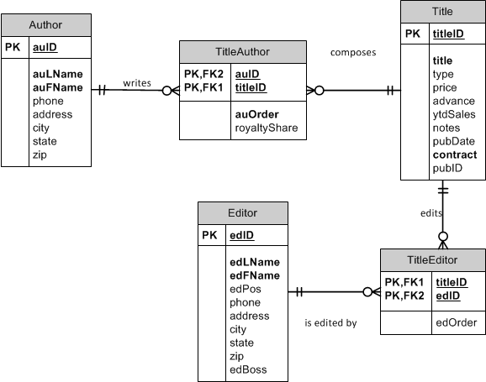

Consider this view:
CREATE OR REPLACE VIEW CompleteBookInfo
AS
SELECT a.auID, auLName AS AuthorLast, auOrder, t.titleID, title, e.edID, edLName AS EditorLast, edOrder
FROM Author a JOIN TitleAuthor ta ON a.auID = ta.auID
JOIN Title t ON ta.titleID = t.titleID
JOIN TitleEditor te ON t.titleID = te.titleID
JOIN Editor e ON te.edID = e.edID;

Author |  | TitleAuthor | Title |  | Editor |  | TitleEditor
auID | AuthorLast | auOrder | titleID | title | edID | EditorLast | edOrder

Is this view updateable?
- No.

Why?
- There is no key-preserved table!
- The key of the view comes from the many sides, which in this case is TitleAuthor and TitleEditor:
titleID, auID, edID
- Since no one table has that combination as a key, there is no key-preserved table. Therefore no updates can be made.

Can try some updates:
UPDATE CompleteBookInfo
SET auOrder = 5
WHERE titleID = 'BU1032';

UPDATE CompleteBookInfo
SET AuthorLast = 'Lung'
WHERE auID = '213-46-8915';

UPDATE CompleteBookInfo
SET edOrder = 5
WHERE edID = '321-55-8906';

